JRPGs – Past and Present

Beyond Triple A: Games with Substance

Adam Gincel

Adam Gincel

HAR 495

17 October 2016

Professor O’Brien

JRPGs – Past and Present

The Japanese Role-Playing Game, or JRPG as we know it today, can find its roots on the Nintendo Entertainment System. Games like *Dragon Quest* and *Final Fantasy* solidified a lot of the conventions that had been introduced in PC RPGs like *Zork*, and added their own concepts that became mainstays in the genre. Turn-based combat, overworld exploration, NPC dialogue, linear storylines that read similarly to novels or other works of fiction, and inventory management are all found in these games. As gaming technology progressed, the presentation of these games improved dramatically, and games like Final Fantasy VII moved the genre towards a more theatrical experience, with exposition delivered in high quality cutscenes. While visual quality moved forward with hardware improvements, other games pushed the genre forward by refining the characteristics core to its games. *EarthBound*, a game developed by Ape and released by Nintendo for the SNES, is one such game. Its tone, atmosphere, storytelling, combat, and general mechanics pushed the boundaries of the JRPG genre and showed that there were plenty of ways to innovate within it. Its influence can be found in JRPGs seen since. An indie JRPG released in 2010 by the name of *Space Funeral* shows its roots in games like *EarthBound*, while deliberately subverting some of them to play with the expectations of the player. This dichotomy between genre-defining and genre-subverting is fascinating, and it is integral to understanding the evolution of the JRPG.

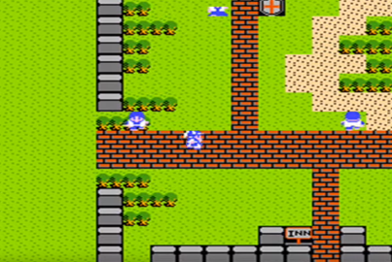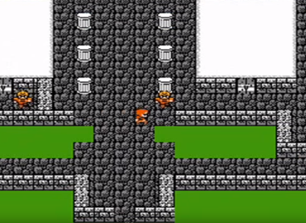RPGs on the whole found their beginnings in tabletop games like *Dungeons & Dragons*, and computer adventure games like *Colossal Cave Adventure*. They were narrative experiences, generally taking place in a fantasy setting. *Final Fantasy* and *Dragon Quest*, the two pioneers of the genre, look fairly similar at a glance. They had similar mechanics; their combat, party management systems, NPC interactions, and methods of overworld exploration were nigh identical. Regardless, these games were critically acclaimed and helped set the gold standard for JRPGs of the time. Both games had many sequels and performed very strongly. Through them, the genre had proven its appeal, and was in the gaming sphere to stay.

*Final Fantasy* (left) and *Dragon Quest* (right) were both fantasy games with similar aesthetics.

*EarthBound*, known as *Mother 2* in Japan, is the sequel to the Japanese-exclusive *Mother*, a game released for the Famicom in 1989. *Mother* was well received in Japan, and performed well enough to get a sequel. *Mother 2*, according to critics, improved upon *Mother* in just about every way, and provided “a satirical deconstruction of RPGs,” rather than the JRPG clone provided by the original. (Parish 1) *EarthBound* takes place in the year 199X in Eagleland, an interpretation of the late-20th century United States. It placed great emphasis on emotional response, staying “quirky and goofy”, and aimed to be accessible to a broader target audience than most JRPGs were at the time. (Schreier 1) In the Japanese version, all dialogue was written in kana script, which made NPC interactions feel more like conversations.The game is remarkably immersive; entire areas are functionally pointless to the progression of the game, instead serving to help engross players in the world. For example, a house may have five residents who all talk about their day or their life while providing no direction and yielding no tangible benefits to the player. These characters are effectively pointless from a pure gameplay perspective; however, removing them from the game would sacrifice some of its identity, and would rob the player of a piece of the world *EarthBound* works so hard to convey. These moments make players feel like they are interacting with a living, breathing world by imitating connections between real people. This increased emphasis on establishing a more intimate world was pioneered by *EarthBound*; games like *Final Fantasy* never took a friendly role with their audience, instead only providing strict lore and plot information. JRPGs seen since have taken more cues from *EarthBound.*

*Space Funeral* was released in 2010 to minimal fanfare on GameJolt.com. The game was released for free by Stephen Murphy, also known as “thecatamites.” *Space Funeral* is a JRPG solo project, which now has a small cult following, not entirely unlike *EarthBound*. To date, almost 70,000 people have played *Space Funeral*, which is around half of the 140,000 copies *EarthBound* sold in North America. Considering the scope of the project and the differences in budget and team size, these figures show just how much the field of game development has changed in the past 30 years. Murphy uses *Space Funeral* to deliberately subvert many expected JRPG tropes and to toy with audience expectations. He is only able to do this because he was, like most of his generation, raised on games like *Final Fantasy*; by being aware of the tropes and conventions of the genre, he is better able to tamper with the audience’s comfort zone. *Space Funeral* stands out from games like *Final Fantasy* and *EarthBound* if only because it was not meant to meet audience expectations or to sell well – it was a work of artist indulgence that was designed to Murphy’s own whims. The creator’s twisted psyche and unique sense of humor permeate its world and provide a memorable, bizarre, and occasionally disconcerting experience to the player that one would never find in a game made by a bigger team or studio.

Aesthetics play a rather large role in public perception of a game. This has been true for a long time in mainstream gaming – one of the main reasons *EarthBound* performed so poorly was its simplistic visuals. Interestingly, one of the most striking and memorable features of *Space Funeral* is its absolutely jarring visual style. The game actually provides an in-universe explanation for the twisted state of the world,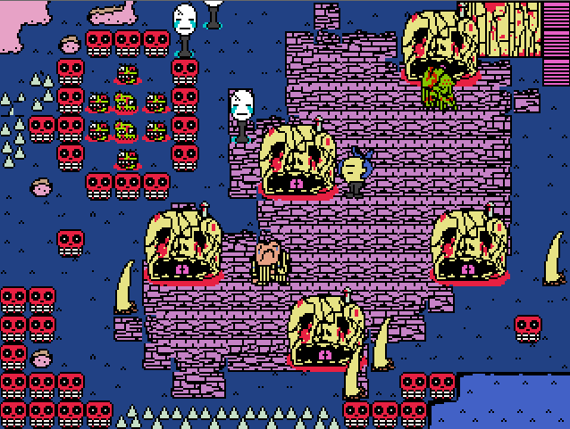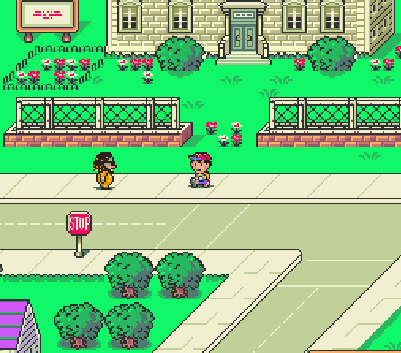 and continues to play with player expectations regarding visuals until the final segment, where the game looks legitimately broken. On the other hand, *EarthBound*’s unique battle backgrounds and consistent art style work well to convey tones of happiness, fear, and sorrow throughout the story. These culminate in the battle with *EarthBound*’s final boss, Giygas, which has been described as being memorable for its "feeling 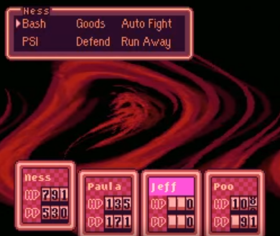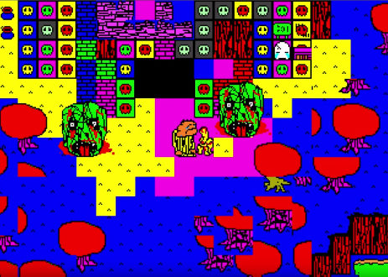of isolation, ... incomprehensible attacks, ... buzzing static … [and emphasis on] prayers." (Oxford 1) These games show that visuals play a key role in audience interpretation of a game, and can be used in many ways to elicit responses both in gameplay action and in player emotion.

*Space Funeral* (left) is notorious for its intentionally jarring visual style while *EarthBound* (right) was criticized for its simplistic visuals.

*Space Funeral*’s final area (left) is deliberately glitchy and broken in appearance. *EarthBound*’s final boss (right) is very surreal and disquieting.

*Space Funeral*, similarly to *EarthBound*, features a lot of world-building and flavor text delivered by NPCs effectively inconsequential to the gameplay or overarching plot of the game. These NPC interactions range from scary, to funny, to outright confusing, and help to break the 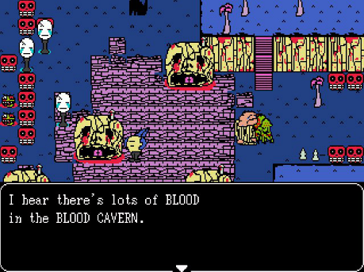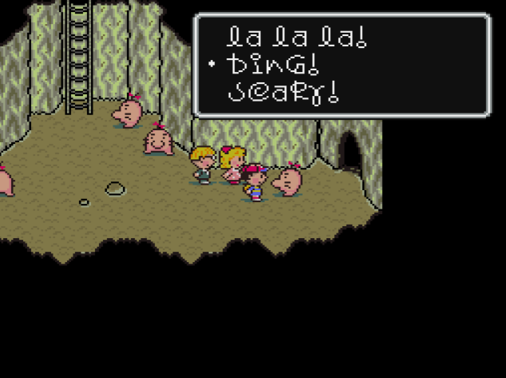flow of the game. As is the case with *EarthBound*, while these conversations are useless to the player’s progression of the game, they add a lot of charm and moments that change a user’s experience with the world, and are thus meaningful parts of the title. These interactions have become very common in JRPGs and *EarthBound* and *Space Funeral* are no exception.

NPC interactions in *Space Funeral* (left) and *EarthBound* (right).

Combat makes up a considerable portion of the time spent playing most JRPGs. *EarthBound* is no exception, and its combat was unique for its time with the introduction of a rolling health meter stylized like an odometer. It allowed party members to survive otherwise fatal hits and was a small, simple way of showing that there was room to innovate on traditional turn-based JRPG combat. *Space Funeral*, built using RPG Maker 2003, used a mostly prebuilt Active Time Battle system that was introduced by *Final Fantasy IV* from Square Enix, where party members have a meter that fills over time that indicates when they can take their turn. Gameplay progression through combat in JRPGs tends to follow an exponential system: player characters get stronger fairly easily early in the game but take much more time to strengthen as the game progresses. *EarthBound* follows this system, but *Space Funeral* rejects it, leaving combat progression practically linear throughout the story and making combat fairly easy throughout. It is not very difficult to complete *Space Funeral* without ever seeing a game over screen, which was a deliberate design choice. Combat in JRPGs is also typically intrinsically tied to the game’s party members. These are typically the main character’s companions who have different classes, characterized by specialized combat skills ranging from increased defense to the ability to heal the team. *Final Fantasy*’s party members were decided upon at the beginning of the game. The player decided what classes they wanted the party to consist of, and gave each member a unique name. Besides this, the characters were not usually fleshed out and were not integral to the story, aside from being in the main character’s party. *EarthBound* began to change this; each party member is given a large portion of screen time as a unique character with their own personality, interests, and goals. They join the team, react to events, and help the main character both in and out of combat. This adds to the player’s perception that there are people in this world besides themselves, and that they are not facing the challenges of the game alone. *Space Funeral* introduces a single party member who joins the protagonist early on. Both *EarthBound* and *Space Funeral* stand out in terms of their combat parties as every character in the party has a specific, unchangeable class. This results in the player having no agency in the composition and abilities of the team beyond what the game gives them. The personalities these characters add to their respective games make up for their lack of customizability, and they give each game a more recognizable, memorable identity.

JRPGs have occasionally used their stories as political platforms. The earliest *Final Fantasy* games often discussed patriarchal kingdoms and how leaders are not infallible, while more recent entries in the series discuss more nuanced subjects, like *Final Fantasy XIII*’s plot about the fear of, and subsequent relocation and termination of, a specific group of people. More interestingly, JRPG settings and scenarios tend to reflect something about the culture or society of their creators. *EarthBound* was made in Japan, a country that is known to suffer from chronic depression, a culture of overworking, and from the decline of intimate relationships. Despite these things, Ape produced a game depicting a world where virtually every character wants to be friends with each other and is generally altruistic, except for certain evil entities influenced by the main antagonist. *Space Funeral*, on the other hand, is a commentary on the futility of pursuing perfection in art. The main antagonist, who is only introduced near the end of the game, was an artist who sought perfection in all things. He looked for inspiration in what was described as the perfect city, which was so immaculate it outshined anything else that could ever exist. Only by corrupting that city and the entire world, the artist reasoned, could beauty be found again. Upon the artist’s defeat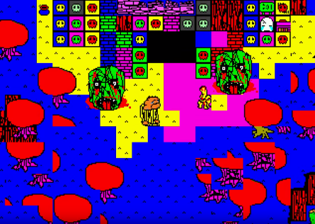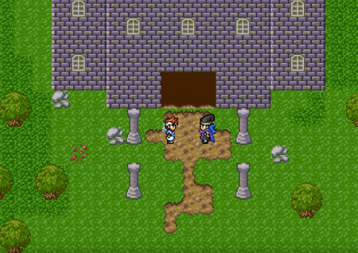, the protagonist and his companion exit the building to find the world restored to its original form: a generic but aesthetically pleasing RPG. The credits then roll, leaving the player wondering if perhaps there wasn’t something beautiful about the chaotic and formless state of the game before its climax after all. These thought provoking situations and scenarios are made special in JRPGs, as the genre can explore themes of friendship, loneliness, fear, and the human condition, or can explore more abstract artistic ponderings. This flexibility in presentation and in tone is part of what makes JRPGs so special.

*Space Funeral*, before and after the climactic battle with the artist who corrupted the world in search of beauty

Japanese Role-Playing Games have been around since the late 1980s, and are approaching their 30-year anniversary. In that time a ton of innovation has changed the genre and given it the ability to convey more complex stories and ideas, while iterating on and improving upon the gameplay that made the earliest JRPGs popular. The games have become better at engrossing their audience in fantastic worlds that can explore real issues and themes through special lenses. The genre has advanced to where it is today because of games that pushed its boundaries, either by taking risks and trying unexplored ideas within the space, or by deliberately rejecting certain conventions set by the games before them. Both *EarthBound* and *Space Funeral* provided unique insights into the history, development, and potential of the genre by telling nuanced stories, communicating deeper themes, and by using audience expectation to their advantage to elicit emotional responses that would last on their players. They came from completely different backgrounds, but they both provide unique insight into the overarching narrative of the history of the JRPG.

Citations

Oxford, Nadia (July 23, 2013). ["EarthBound's Ten Most Memorable Moments"](http://www.ign.com/articles/2013/07/23/earthbounds-ten-most-memorable-moments). IGN. Ziff Davis.

Parish, Jeremy (April 22, 2007). ["Hall of Fame: EarthBound Zero"](http://www.1up.com/do/blogEntry?bId=8067071&publicUserId=5655917). *1UP.com*. Ziff Davis.

Schreier, Jason (August 23, 2013). ["The Man Who Wrote EarthBound"](http://kotaku.com/the-man-who-wrote-earthbound-1188669175). Kotaku. Gawker Media.